“Movie Dataset Analysis using SQL”

📌 Project Description
This project focuses on analyzing a movie dataset using SQL to extract meaningful insights. The objective is to understand the structure of the data, perform data cleaning, and explore patterns such as trends in release years, missing values, and distribution of different attributes.
SQL is used to query the dataset, check data quality, and answer analytical questions that are useful for decision-making. This project demonstrates practical SQL skills required for a data analyst role.
🔍 Step 1: Understanding Dataset Structure
✅ Query:
DESCRIBE titles;
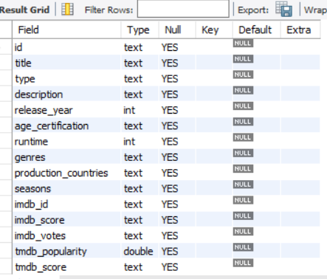

📊 Explanation:
This query shows the structure of the dataset including column names, data types, and whether NULL values are allowed.
👉 Insight:
We understand what type of data is available and how it is stored.

📊 Step 2: Preview the Data
✅ Query:
SELECT * FROM titles
LIMIT 5;
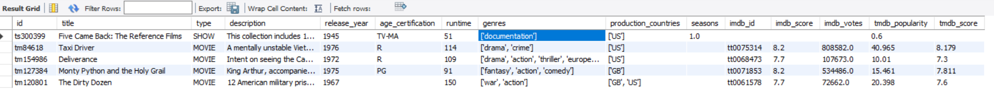
📊 Explanation:
This query displays the first 5 rows of the dataset.
👉 Insight:
Helps to understand how the actual data looks and identify possible issues.

📌 Business Questions Solved
- What is the average rating of movies vs shows?
- How has content production changed over decades?
- Which age certifications have higher ratings?
- What is the average runtime of content types?
- Which shows have the most seasons?
- How many titles are released each year?

🎯 Step 3: Average IMDB and TMDB Scores by Content Type
✅ Query:
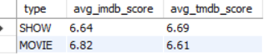
SELECT type,
ROUND(AVG(imdb_score),2) AS avg_imdb_score,
ROUND(AVG(tmdb_score),2) AS avg_tmdb_score
FROM titles
GROUP BY type;

📊 Explanation:
This query calculates the average IMDB and TMDB scores for each content type (Movies and TV Shows). The ROUND() function is used to limit the values to 2 decimal places for better readability.
💡 Insight:
It helps compare the overall ratings of movies and shows, showing which type of content generally receives higher audience ratings.

🎯 Step 4: Count of Movies and Shows by Decade
✅ Query:
SELECT
CONCAT(FLOOR(release_year / 10) * 10, 's') AS decade,
COUNT(*) AS movies_shows_count
FROM titles
WHERE release_year >= 1940
GROUP BY CONCAT(FLOOR(release_year / 10) * 10, 's')
ORDER BY decade;
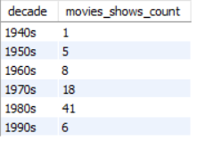

📊 Explanation:
This query groups movies and shows into decades (like 1980s, 1990s) using the FLOOR() function. It then counts how many titles were released in each decade. The WHERE clause filters data from 1940 onwards.
💡 Insight:
It helps identify trends in content production over time, showing which decades had the highest number of releases.

🎯 Step 5: Average IMDB and TMDB Scores by Age Certification
✅ Query:
SELECT age_certification,
ROUND(AVG(imdb_score),2) AS avg_imdb_score,
ROUND(AVG(tmdb_score),2) AS avg_tmdb_score
FROM titles
WHERE age_certification IS NOT NULL
AND age_certification <> ''
GROUP BY age_certification
ORDER BY avg_imdb_score DESC;
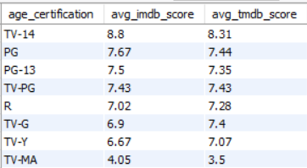

📊 Explanation:
This query calculates the average IMDB and TMDB ratings for each age certification category (such as PG, R, etc.). The data is grouped by age certification and sorted by IMDB score in descending order.
💡 Insight:
It helps understand how content ratings relate to audience scores, showing which age categories tend to receive higher ratings.
🎯 Step 6: Average Runtime by Content Type
✅ Query:
SELECT
type AS content_type,
ROUND(AVG(runtime),2) AS avg_runtime_min
FROM titles
GROUP BY type;
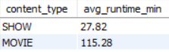

📊 Explanation:
This query calculates the average runtime for each content type (Movies and Shows) by grouping the data based on the type column. The ROUND() function formats the result to 2 decimal places.
💡 Insight:
It provides a direct comparison of the average duration of movies and TV shows, helping to understand differences in content length.

🎯 Step 7: Top 10 Shows with the Most Seasons on Netflix
✅ Query:
SELECT
title,
SUM(seasons) AS total_seasons
FROM titles
WHERE type = 'Show'
GROUP BY title
ORDER BY total_seasons DESC
LIMIT 10;
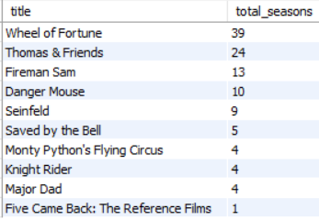

📊 Explanation:
This query filters only TV shows and calculates the total number of seasons for each title. The results are sorted in descending order to identify the shows with the highest number of seasons, and only the top 10 are displayed.
💡 Insight:
It helps identify long-running shows on Netflix, which are often more popular or successful over time.

🎯 Step 8: Total Number of Titles Released Each Year
✅ Query:
SELECT
release_year,
COUNT(*) AS title_count
FROM titles
GROUP BY release_year
ORDER BY release_year DESC;

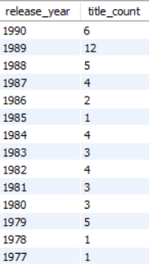

📊 Explanation:
This query counts how many titles were released in each year by grouping the dataset based on release_year. The results are sorted in descending order to show the most recent years first.
💡 Insight:
It helps identify trends in content production over time, such as growth in recent years or periods with fewer releases.

📊 1️⃣ Key Insights
- Movies and TV shows differ in both average ratings and runtime
- Content production has significantly increased in recent decades
- Age certification influences audience ratings
- A small number of shows have very high season counts, indicating long-term popularity
- Recent years show a higher volume of content compared to earlier periods
📈 2️⃣ Limitations of the Dataset
- Some columns contain NULL or missing values
- production_countries may include multiple countries in one row
- Data may not represent all global content accurately

🔧 3️⃣ Tools & Technologies Used
- SQL (MySQL)
- Dataset for movie analysis
- Query-based data exploration

🎯 4️⃣ Conclusion (FINAL SECTION)
This project demonstrates how SQL can be used to explore and analyze a dataset effectively. By performing data cleaning, aggregation, and trend analysis, meaningful insights were extracted from the movie dataset.
The analysis highlights patterns in content production, ratings, and distribution, showcasing practical skills required for a data analyst role.
This project demonstrates practical SQL skills such as data cleaning, aggregation, and analytical querying, which are essential for data analyst roles.

